**Statement of Confidentiality**

|  |
| --- |
| © Access Health International.  This is a controlled document. Unauthorized access, copying, replication or usage for a purpose other than for which it is intended, are prohibited.  All trademarks that appear in the document have been used for identification purposes only and belong to their respective companies. |

1. **Functional Area-Plan**
   1. **Purpose**

This document describes the Functional and Technical Requirement Specification (Business Requirement Specification) for Consultation service as an outcomein a primary and specialist care setting. Since consultation service is a complex functional area and comprises of multiple smaller service area, we have divided it into smaller microservices. We have followed the **SOAP** note (**Subjective, Objective, Assessment, Plan**) method which is a worldwide adopted method of writing a clinical summary for a patient encounter note. This document covers specifications for “Plan (Prescription)”based on the information which is captured by a Doctor/ Nurse during a patient consultation.

* 1. **Intended Audience**

This document is intended for the Product Engineering team to commence development of‘Consultation (P)’ microservice and the audience would comprise of

* + 1. Development, Design & Implementation Team which may include Architects, Designers, Developers, and Business Analysts
    2. Key stakeholders in the government at central and state levels
  1. **Overview**

In any clinical setting during a patient consultation, the healthcare provider (Doctor/ Nurse) captures patient’s critical health information which is required to arrive at the diagnosis and treatment plan for a patient. There are various formatsor templates available for capturing such information. A SOAP (Subjective, Objective, Assessment& Plan) note in consultation is a way for healthcare professionals to document the information in a structured & organized way and is being used worldwide by the medical professionals. It also guides the professionals for evaluating information and provides a cognitive framework for clinical reasoning. The structure of documentation is a checklist with defined flow that serves as a cognitive aid and a potential index to capture and retrieve information about a patient’s health.

The current document will cover “Plan” component of the SOAP note. The Plan component will cover-Clinicals Order (Medication, Lab Investigations, Radiological Investigations, Procedures and Care Services); e-Referral;Follow-up Orders. This document will also cover quick order functionalities like Repeat Order, Favorites,Recent order and group service ordering i.e Order set functionality. These functionalities are required by public and private health facility setting where patient footfall per day is critically high.

* 1. **Scope & Not in Scope**

Functionality scope includes:

* SOAP- Plan (Prescription)
  1. **Business Process Flow**
     1. **Business Process Flow for Consultation (P)**

|  |  |
| --- | --- |
| **Description** | Based on the Assessment section where a health care provider arrives at a diagnosis (provisional or final), based on which a care provider will come up with a relevant treatment plan and prescription. The “Plan” part of SOAP will be used to enter various clinical orders for the patient to manage his health conditions. The clinical orders will cover Medication-Rx orders, Lab investigation order, Radiology Investigation orders, referral and follow up orders. The orders may then feed into worklist of care givers at various level for service/order rendering or drug/vaccine administration at facility or community level.  The P (Plan) component of a SOAP note will primarily covers the following:   * Lab & Radiology Investigation Orders * Procedure Orders * Rx Orders * e-Referral Order – It will cover the inter-department referral and inter-facility referral * Follow-up Orders – It will cover recurring appointments/ consultations/patient visits   The plan part should also cover quick order functionalities such as:   * **Order Sets**- This functionality enables placing group orders for a patient. This functionality is used to save time in a clinical setting where patient flow is high. An order set can be defined as per the specialty, patient groups and health condition or diagnosis or patient screening for a specific health condition. * **Favorites**- This functionality can be used by a care provider to create favorite set of orders that he/she would order for his/her patients. This list is user specific and is configurable. * **Recent/frequent Orders**- This is a system feature that can keep recent or frequent orders on top of the order list that a care provider can quickly order with one click or tap. * **Repeat orders**- This functionality is required when a care giver wants to repeat existing active orders from prescription list or orders that are required to be repeated at regular interval or frequency. Eg: Blood sugar test for a chronic diabetes patient. * **Refills**- Refill can be used when a patient is under treatment for a long term/prolonged condition where regular refills of drugs is required. A care giver can set frequency of refills for a patient that can autogenerate drug orders for a patient and a notification/reminder can be set for patient as well as pharmacy in question. |
| **Users** | Nurse, Doctor |
| **Pre-requisites** | The ‘Subjective’, ‘Objective’ and ‘Assessment’ sections of the SOAP note is complete  Active episode ID  Active encounter ID |
| **Business Process Details** | Based on the assessmenti.e diagnosis, the consulting doctor may prescribe medications, order investigations for confirmation, procedures, care services (if needed)etc. The ‘Plan’ may also involve advising for referral services which may be within the facility or outside the facility. Additionally, some illnesses may need recurring appointments over time and need to be captured in the ‘Plan’ using follow up orders.  This section would serve as a guiding document for the care plan of the patient and will follow the ‘Subjective’, ‘Objective’ and ‘Assessment’ components of the SOAP note. |
| **Steps** | The consulting doctor/ nurse will use the ‘Plan’ section of the SOAP screen to enter clinical orders for the patient either by selecting orders individually or using order sets.  As explained in the previous parts of the document a plan functionality allows a healthcare provider to place different type of patient orders using the same UI. The various orders may include Lab, Radiology, Procedure/therapy, Drugs, referral and follow up orders (Scheduled visits- RCH ANC visits)   * Every prescription (Clinical orders) that is generated during an encounter should have associated episode and unique encounter ID. * Every prescription generated will also have a prescription ID. All the different type of orders that were placed will be linked to the prescription ID. * Every order which will be part of a prescription should have unique order ID for order tracking administration or service rendering and result management. * Every ordering module should support configuration of responsibility to generate a triggered workflow for a department, patient or health worker to service the order placed by the physician. * An order can be placed individually through respective service/drug search master/registry or can be placed using a predefined diagnosis or condition based order set.   **Brief about Ordersets**   * Order sets are nothing but group of orders that can be preconfigured and kept by the facility or physician to place all medication, investigation, procedure and follow up orders with single search or click. * The order set will provide the Doctors/Nurses with a pre-decided group of orders pertaining to a specific diagnosis. It would have details of the medication, investigations (lab/radiological), procedure (if any), care services (if any). * An order set can be used against a diagnosis i.e can be filtered using a diagnosis and can be added through the “Assessment “part of SOAP and can be associated with an ICD code. * It can also be set by the physician for a patient group or screening purpose and can be directly added through the plan part of SOAP itself. * The Doctor/Nurse should be able to search the required order set as per the specialty or diagnosis. * The order sets could be edited depending on patient needs and diagnosis. * The selected order set upon final submission would reflect in the order list of respective departments.   **Investigation Orders (LOINC codes)**   * System should support LOINC codes for placing lab investigation orders * Either a complete set of LOINC code sets with investigation listshould be available in the application masters   or   * System should facilitate mapping their lab investigation list with relevant LOINC codes as LOINC is a recommended standard as per NDHB and EHR standards of India and will facilitate interoperability across applications and health care settings. LOINC is an international standard which is in use worldwide by Healthcare delivery applications. * LOINC's goal is to create different codes for each test, measurement, or observation that has a clinically different meaning. To do that LOINC codes distinguish a given observation (test ordered/reported, survey question, clinical document) across six dimensions that we call Parts. It is owned, maintained and distributed by Regenstrief Institute, Inc. USA. * LOINC has two main parts: laboratory LOINC and clinical LOINC.   Each database record includes six fields for the unique specifications of each identified single test, observation, or measurement:    **Critical points to implement LOINC**   * Master tables should have reference data to generate six components to generate axial components of LOINC code. * The laboratory LOINC is comparatively easier to generate as lab modalities come supplied with master reference data needed to generate LOINC code however the generation of clinical LOINC code is challenging as there is no uniformity at the master table reference data used in clinical systems. * **Licensing terms** – LOINC codes are available free of cost for use from Regenstrief Institute, Inc., USA (distributed in India by NRCeS CDAC Pune)   **Steps to place a lab order-**   * An authorized user Doctor/Nurse can add a lab investigation order against a patient encounter and active episode. * **Investigation lookup or search**-User searches relevant investigation using textual or codified search from the LOINC based investigation master list. * Recent/favorite **orders**-The user Interface may facilitate single click/tab function to select recent or favorite orders for the user to quickly place an order. * **Repeat orders**-For each lab investigation order, system needs to capture ***frequency or interval*** if the test must be repeated for patient on a predefined interval. Eg: fasting Blood sugar should be taken every day for 15 days for a diabetic chronic patient. * **Responsibility**-Application should be capable of **configuring the responsibility** of an order placed. Eg: The fasting blood sugar can be performed by the patient himself daily at home or can be an order for an integrated or third part lab that can kick start the sample collection process or even a task of an ASHA worker. * As per the configured responsibility a worklist can be auto generated for a health worker or lab or department. * **Special Instructions**-While setting up the lab investigation master “special instructions” can also be configured against an investigation that can be shared with patient with the prescription. * **Current Investigation List**-Once an investigation is selected it gets added in the current investigation list. * **Past Investigation List**-In later / follow up visits a result value or report attachment can be seen against the same investigation code but will be seen in past investigation orders. It is easier for the user from a UI perspective to check the results against the investigation order in the same screen. (Reduces number of clicks). An order remains in the current investigation order list only for that encounter/visit.   **Procedure orders (Radiologyprocedures as well)(LOINC codes)**   * A standard procedure code (SNOMeD (NDHB)), CPT, ICD10-PCS etc) can be used to place radiology orders for a patient. * Orders may also include some procedures like biopsy. * The procedure order will have fields like procedure name, procedure type, procedure code, responsibility etc. * **Procedure Search/lookup**- User searches relevant procedure using textual or codified search from the master list. * **Favorite/Recent Orders**-User can also select a radiology order from his/her favorite list or recent orders to save time. * **Repeat orders**- A radiology procedure or a therapy can also be repeated by setting up frequency ***or interval*** when the test must be repeated for. * **Responsibility**-Application should be capable of **configuring the responsibility** for the order placed. * As per the configured responsibility a worklist can be auto generated for a health worker or radiology department or department. * **Current Procedure Order**-Once a procedure is selected it gets added in the current procedure list. * **Past Procedure List**-In later / follow up visits a result value or report/procedure notes/ attachment can be seen against the procedure order but will be seen in past order list. It is easier for the user from a UI perspective to check the results/notes against the procedure order in the same screen. (Reduces number of clicks). An order remains in the current procedure orders only for that encounter/visit.   **Medication or Rx Orders-**   * A medication order can be added either by searching each medication from the drug master list or can be preconfigured as part of the order sets for a diagnosis. * All the active medications should be seen in the UI provided for new medication order, as it gives the treating doctor visibility of active patient medication. Doctor/nurse can then use checkboxes or other UI attributes to select the same medication if it is to be repeated for a course of treatment using repeat and refill functionality. * **Order Sets-** A Doctor should also have the authorization to edit any pre-configured order set while ordering for a patient. As slight deviations or dosage/frequency can be changed based upon the patient gender/age/type and health condition severity, which he/she can repeat or make it sticky. * **Drug registry/drug master lookup or search (Dynamic search)**-User should be able to searchthe relevantdrug usinga dynamic search. It should be as simple as google search functionality that it autosuggests the medication when the user starts typing generic/brand name with strength and form details. The database should store the drug information segregated as separate elements for each drug parameter. Some of the elements to store a drug includes “Generic Name, Brand name, Strength, Form, Dosage(Configurable from the standard list), and frequency. * **Recent/favoriteRxorders**-The user Interface may facilitate single click/tab function to select recent or favorite drug orders for the user to quickly place an order. * **Repeat orders**-For each drug order, system should allow the user to repeat one or multiple active or past drug orders. It will reduce the number of clicks a user has to make to place one drug order. * **Order Responsibility**-Application should be capable of **configuring the responsibility** of an order placed. Eg: In case of a government Tuberculosis program the drug administration can be done by the patient himself daily at home or can be an order for an ASHA worker. Depending upon the preconfigured responsibility against an order or order set, system can generate worklist for the responsible user/department/. * **Special Instructions**-While setting up the drug master “special instructions” can also be configured against a drug order that can be shared with patient with the prescription or can be added as comment. * **Alerts**- A drug order functionality should support alerts and approval flow for various drug interactions that includes Drug-Drug allergy, Drug-drug (when two drugs cannot be prescribed together as may result in contradiction, Drug-lab (certain lab investigations do not show expected result outcome when a patient is on a certain drug), Drug-Gender, Drug-Age and drug duplication (in case of same generic or presence of an existing drug order) * **Stop Drug Order**- The treating physician should be provided a feature to stop an active drug order using the same drug Order UI. This is required in cases where a Doctor wants to change a drug for the patient in the follow up visits. * **Active DrugOrders**-All the active drug orders should be always visible in the Rx order UI to enable drug order reconciliation. * **Past DrugOrders**- All the drugs that have been stopped by the treating doctor or as per the prescribed days result value or report attachment can be seen against the same investigation code but will be seen in past investigation orders. It is easier for the user from a UI perspective to check the results against the investigation order in the same screen. (Reduces number of clicks). An order remains in the current investigation order list only for that encounter/visit. * For creating the Rx order, the doctor/nurse will open the medication tab and based on the diagnosis would look up for the respective medication from the **facility’s Drug master / National Formulary of Indi**a (recommended). * The Rx order will have the medication **generic name, Brand name, medication code, dosage, route of administration, frequency of medication and duration of medication, refill feature and repeat checkboxes**etc.The detailed fields are provided in later part of the document. * User can add additional instructions as per the facility or Rx order requirement. * **Textual/dynamic search**- user can search the required drug generic from the drug list by typing the generic/brand name. The search suggestion should show drug name with generic, strength and form. * **Sticky Order**- An Rx order that a doctor wants to keep active for a long period of time for treating a patient condition can be marked as sticky. On marking a drug order as sticky the order will always be seen in the active drug list and refill intervals can be set for the same that will generate notifications for the patient or health worker or pharmacy to refill the active drug.eg: in case of tuberculosis course of treatment or a chronic disease management a medication remains active for a certain prolonged period or even for lifetime. A simple toggle button or checkbox can be used to make a drug order sticky. Only when the doctor will stop this type of drug order, it can be removed from active orders. * **Immunization orders-** the same screen can be used to place vaccine orders for a patient with predefined responsibility that can be set up in the masters as per the order/service category type. A drug order remains active as per the dosage provided by the Doctor and once closed is moved o the past medication orders.   **eReferral:**   * In case the patient needs to be referred to another consultant within the facility or outside the facility, the doctor/ nurse can use thethe referral order UI which is part of the “Plan” functionality (S-Subjective, O-Objective, A-Assessment, P-Plan) and create referral order. * A referral can be placed to a department within the facility or Doctor within the facility or to a doctor or department outside a facility. * They will either look up for a consultant from the provider registry using a **provider lookup API** orlook up for facility ID (NDHB) using the facility lookup if it is inter-facility that will provide the unique identification number for a doctor or the facility. * For an e-referral a pre-configured referral letter with e-referral object can be generated and shared across departments or facilities to a referred doctor or Facility. * E-referral order should allow the referring doctor to attach the e-encounter note object or if there is a PHR aviable should allow adding pointer of the e-encounter object that referred doctor can use to open and view with patient consent.   **Follow-up Orders**   * In case the patient needs to have recurring appointment or may need to revisit post an investigation, the doctor/ nurse will open the follow-up tab and enter the relevant information with date and frequency of follow up.   **Some key Notes: -**   * On completion of an encounter an **E-encounter object**and **eReferral object** will be generated as an output that can be used to exchange data between different facilities/provider or even for the future patient encounters by the treating physician. * Formats of e-encounter object and e-referral objects are provided in the later part of the document for reference and may be used for designing the structured FHIR resource 4 based JSON container. * Upon submission of an encounter note, the relevant department in the facility will get notifications/ alerts on treatment, referrals and follow-ups as per the order responsibility/ * Upon submission, other relevant facility may get a notification/ alert on treatment/ referral * Application at all time will maintain current/active order list and a past order list. |
| **Outputs** | * E-encounter Note Object * E- Referral Object * E-prescription Order |
| **Messages & Alerts** | * System alert errors on validation * Message to relevant provider/ department for relevant orders * Message to patient/ family member on consultation details |

Business Process Flow for Lab Investigation Order

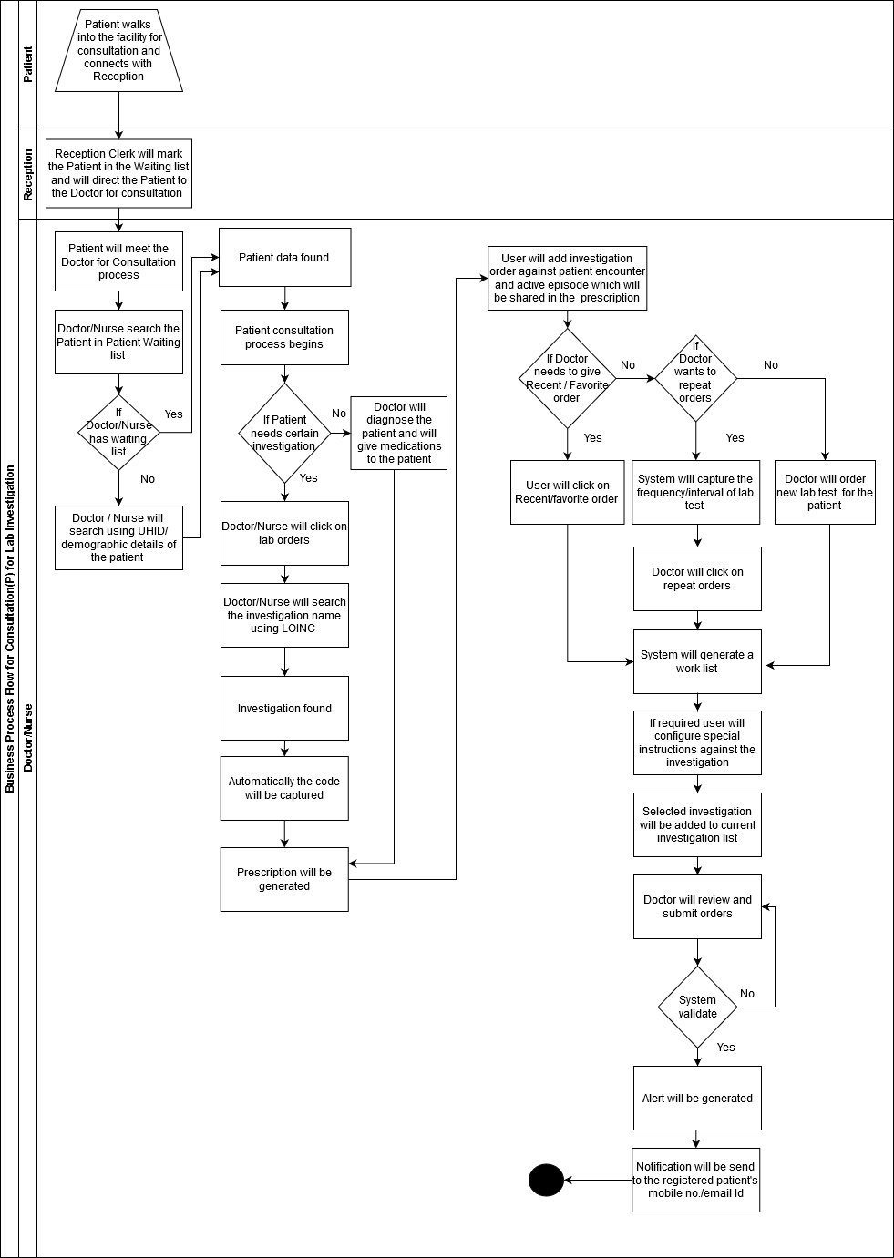

Business Process Flow for Procedure Order

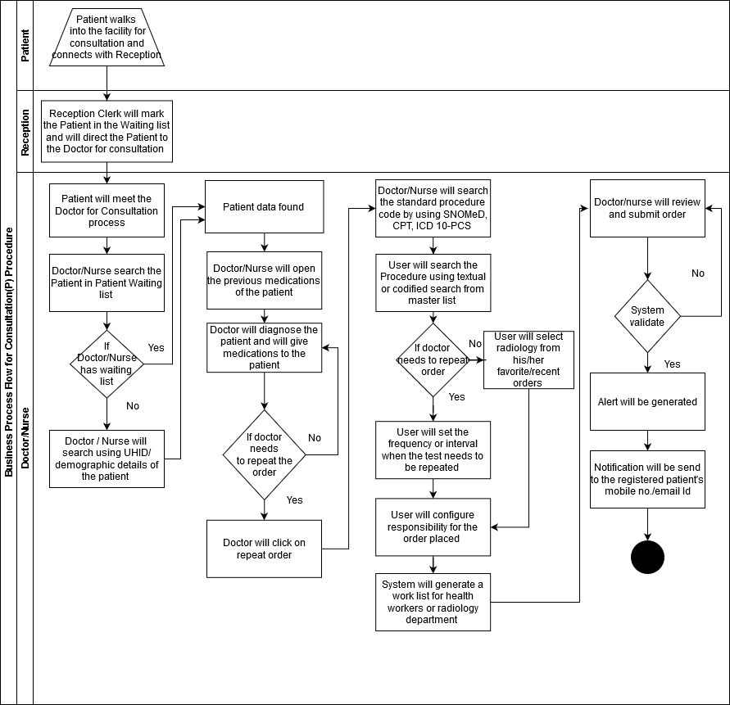

Business Process Flow for Medication Order

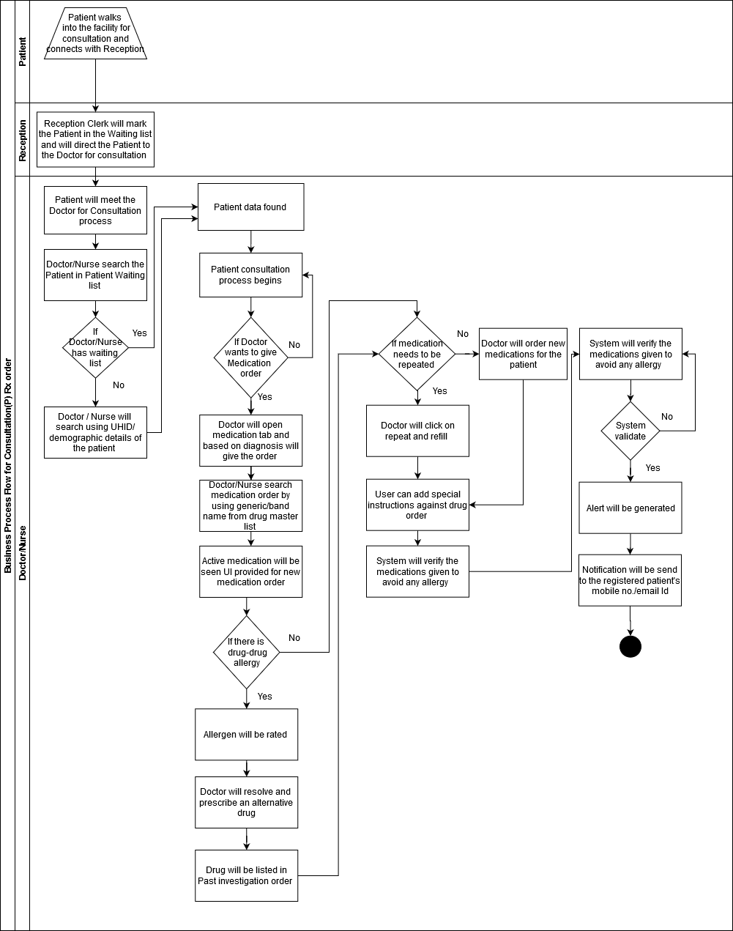

Business Process Flow for e-Referral Order

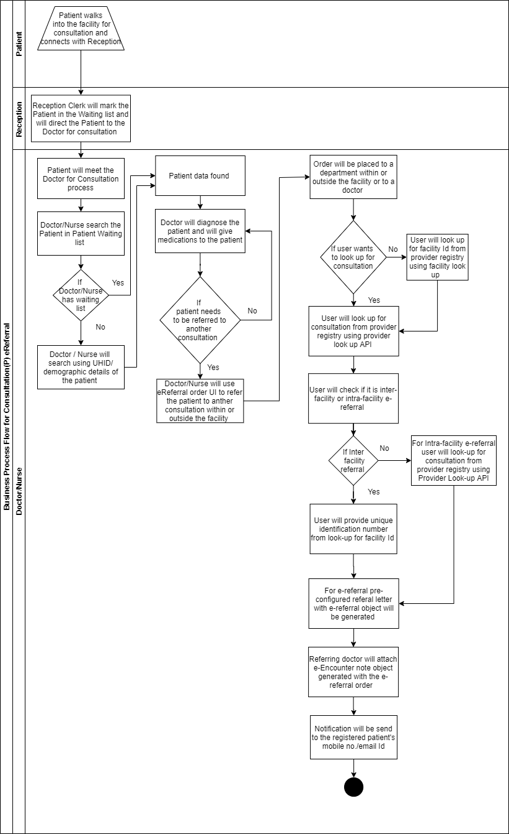

Business Process Flow for Follow up Order

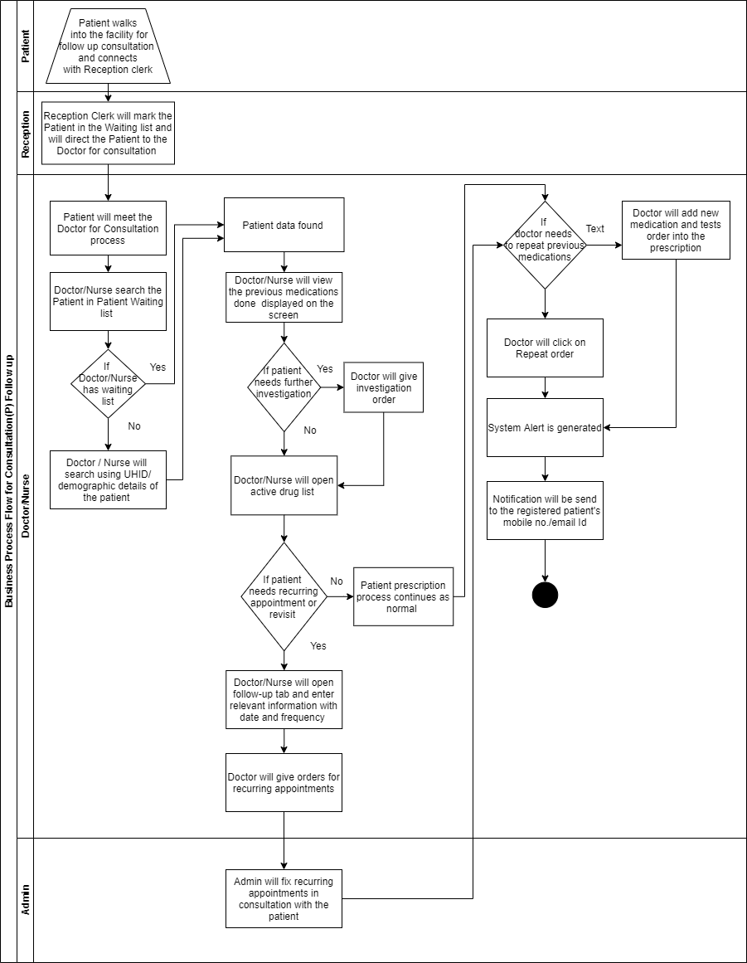

* 1. **Required MDDS Data Elements**
     1. **Entity: Generic**

|  |  |  |  |  |
| --- | --- | --- | --- | --- |
| **Data Elements** | **MDDS Codes** | **Data Format** | **Maximum Size** | **Code Directory** |
|  |  |  |  |  |
| Time | 05.001.0001 | HH:MM:SS | 8 |  |
| Date | G00.01 | dd/mm/yyyy | 10 |  |
| FIR No. | 05.001.0002 | Varchar | 50 |  |
| Alternate Identifier Type | 05.001.0003 | Integer | 2 |  |
| Alternate Identifier | 05.001.0004 | Varchar | 254 |  |
| Alternate Identifier Format | 05.001.0005 | Bytes | 20 |  |
| Comments | 05.001.0007 | Varchar | 99 |  |
| Unit of Measurement | 05.001.0018 | Varchar | 25 | CD05.025 |
| Healthcare Application Number | 05.001.0019 |  |  | CD05.013 |
| Code System Qualifier Type | 05.001.0020 | Char | 1 |  |
| Code System Qualifier | 05.001.0021 | Varchar | 15 | CD05.032 |
| System of Medicine | 05.001.0022 | Integer | 2 | CD05.030 |
| Document ID | 05.001.0023 | Varchar | 50 |  |
| Reference Document ID | 05.001.0024 | Varchar | 50 |  |
| Non-Clinical Document Type | 05.001.0025 | Integer | 2 | CD05.034 |
| Reference Document | 05.001.0026 | Varchar | 254 |  |
| Non-Clinical Document | 05.001.0027 | Varchar | 4096 |  |

* + 1. **Entity: Person**

|  |  |  |  |  |
| --- | --- | --- | --- | --- |
| **Data Elements** | **MDDS Codes** | **Data Format** | **Maximum Sze** | **Code Directory** |
|  |  |  |  |  |
| Unique Health Identification Number | G01.01 | Integer | 12 |  |
| Alternate Unique Identification Number (UID) Type | 05.002.0001 | Integer | 2 | CD05.007 |
| Alternate Unique Identification Number (UID) | 05.002.0002 | Varchar | Max. Size =18 10 - PAN Card 08 - Passp ort No. 18 - Voter ID 18 - Any other Identifier |  |
| Author ID | 05.002.0032 | Varchar | 8 |  |
| Author Name | 05.002.0017 |  |  | G01.02 |
| Author Landline Telephone Number | 05.002.0018 | Varchar | 8 | G00.06- 01-05 |
| Author Mobile number | 05.002.0019 | Char | 10 | G00.06- 02-05 |
| Author Email Address/URL | 05.002.0020 | Varchar | 254 | G00.09 |

* + 1. **Entity: Patient**

|  |  |  |  |  |
| --- | --- | --- | --- | --- |
| **Data Elements** | **MDDS Codes** | **Data Format** | **Maximum Size** | **Code Directory** |
|  |  |  |  |  |
| Provider’s Patient ID | 05.003.0001 | Varchar | 18 |  |
| Patient Name | 05.003.0002 |  | Short Name in English, Varchar 50. Full Name in English,Varchar 99 Short Name in Recognized Official Language, Varchar 30 Full Name in Recognized Official Language, Varchar 99 | G01.02 |
| Patient Landline Number | 05.003.0011 | Varchar | 8 |  |
| Patient Mobile Number | 05.003.0012 | Char | 10 |  |
| Patient Class | 05.003.0013 | Varchar | 254 | CD05.047 |
| Patient Arrival Time | 05.003.0014 | HH:MM:SS | 8 |  |
| Patient Arrival Date | 05.003.0015 | dd/mm/yyyy | 10 |  |
| Pregnancy Indicator | 05.003.0017 | Integer | 1 |  |
| Duration of Pregnancy | 05.003.0018 | Integer | 2 |  |

* + 1. **Entity: Provider**

|  |  |  |  |  |
| --- | --- | --- | --- | --- |
| **Data Elements** | **MDDS Codes** | **Data Format** | **Maximum Size** | **Code Directory** |
|  |  |  |  |  |
| Unique Individual Health Care Provider Number | 05.005.0001 | Varchar | 18 |  |
| Unique Individual Health Care Provider Number Type | 05.005.0002 | Integer | 2 | CD05.008 |
| Registration Authority Number | 05.005.0003 | Integer | 3 | CD05.012 |

* + 1. **Entity: Facility**

|  |  |  |  |  |
| --- | --- | --- | --- | --- |
| **Data Elements** | **MDDS Codes** | **Data Format** | **Maximum Size** | **Code Directory** |
|  |  |  |  |  |
| Facility National Identification Number | 05.008.0001 | Integer | 10 | CD05.001 |
| Facility Global Unique Identifier (GUID) | 05.008.0025 | Bits | 16 |  |
| Facility Type Code | 05.008.0002 | Integer | 2 | CD05.002 |
| Department Name | 05.008.0015 | Varchar | 99 | CD05.090 |
| Referral Facility Identification Number | 05.008.0019 | Integer | 10 | CD05.001 |
| Referral Facility Type Code | 05.008.0020 | Integer | 2 | CD05.002 |

* + 1. **Entity: Episode**

|  |  |  |  |  |
| --- | --- | --- | --- | --- |
| **Data Elements** | **MDDS Codes** | **Data Format** | **Maximum Size** | **Code Directory** |
|  |  |  |  |  |
| Episode ID | 05.009.0001 | Varchar | 50 |  |
| Episode Type | 05.009.0002 | Integer | 1 |  |

* + 1. **Entity: Encounter**

|  |  |  |  |  |
| --- | --- | --- | --- | --- |
| **Data Elements** | **MDDS Codes** | **Data Format** | **Maximum Size** | **Code Directory** |
|  |  |  |  |  |
| Encounter ID | 05.010.0001 | Varchar | 18 |  |

* + 1. **Entity: Outreach (health workers)**

|  |  |  |  |  |  |
| --- | --- | --- | --- | --- | --- |
| **Data Elements** | **MDDS Codes** | | **Data Format** | **Maximum Size** | **Code Directory** |
|  |  | |  |  |  |
| Outreach Service Delivery Place Name | 05.014.0001 | |  |  | G02.02 |
| Outreach Service Delivery Place Address | 05.014.0002 | |  |  | G02.03 |
| Outreach Service Delivery Place Type | 05.014.0003 | | Integer | 2 | CD05.047 |
| Outreach Service Provider Identification Number | 05.014.0007 | | Varchar | 18 |  |
| Outreach Services Treatment Plan Start Date | 05.014.0008 | | dd/mm/yyyy | 8 |  |
| Outreach Services Treatment Plan End Date | 05.014.0009 | | dd/mm/yyyy | 8 |  |
| Referral Support Indicator | 05.014.0010 | Integer | | 1 |  |

* + 1. **Entity: Clinical Notes**

|  |  |  |  |  |
| --- | --- | --- | --- | --- |
| **Data Elements** | **MDDS Codes** | **Data Format** | **Maximum Size** | **Code Directory** |
|  |  |  |  |  |
| Author Time | 05.019.0001 | HH:MM:SS | 8 |  |
| Author Date | 05.019.0002 | dd/mm/yyyy | 10 |  |
| Reference | 05.019.0003 | Varchar | 99 |  |
| Information Source Name | 05.019.0004 | Varchar | 99 |  |
| Clinical Document | 05.019.0005 | Varchar | 4096 |  |
| Clinical Document Type | 05.019.0006 | Integer | 2 | CD05.046 |

* + 1. **Clinical Orders Entity**

|  |  |  |  |  |
| --- | --- | --- | --- | --- |
| **Data Elements** | **MDDS Codes** | **Data Format** | **Maximum Size** | **Code Directory** |
| Clinical Orders Description | 05.025.0003 | Varchar | 254 |  |
| Order ID | 05.025.0004 | Varchar | 12 |  |
| Parent Order ID | 05.025.0005 | Varchar | 10 |  |
| Order Verifying Care Provider ID | 05.025.0006 | Varchar | 18 |  |
| Order Status | 05.025.000 | Char | 2 | CD05.121 |
| Order Priority | 05.025.0012 | Integer | 2 | CD05.048 |
| Placer Order ID | 05.025.0013 | Varchar | 10 |  |
| Filler Order ID | 05.025.0014 | Varchar | 10 |  |

* + 1. **Entity: Lab**

|  |  |  |  |  |
| --- | --- | --- | --- | --- |
| **Data Elements** | **MDDS Codes** | **Data Format** | **Maximum Size** | **Code Directory** |
|  |  |  |  |  |
| Lab Order Code | 05.021.0022 | Varchar | 10 | CD05.024 |
| Lab ID | 05.021.0023 | Integer | 10 | CD05.122 |
| Lab Type | 05.021.0024 | Integer | 1 |  |

* + 1. **Entity: Radiology**

|  |  |  |  |  |  |
| --- | --- | --- | --- | --- | --- |
| **Data Elements** | **MDDS Codes** | **Data Format** | **Maximum Size** | **Code Directory** | |
| Radiology Center ID | 05.022.0001 | Integer | 10 | CD05.094 | |
| Radiology Center Type | 05.022.0002 | Integer | 1 | | CD05.094 |
| Radiology Procedure Name | 05.022.0007 | Varchar | 255 | | CD05.043 |
| Radiology Procedure Code | 05.022.0008 | Varchar | 18 | | CD05.043 |

* + 1. **Entity: Pharmacy**

|  |  |  |  |  |
| --- | --- | --- | --- | --- |
| **Data Elements** | **MDDS Codes** | **Data Format** | **Maximum Size** | **Code Directory** |
| Drug Classification Code | 05.023.0001 | Integer | 2 | CD05.106 |
| Route of Administration | 05.023.0002 | Varchar | 6 | CD05.111 |
| Medication Frequency | 05.023.0003 | Varchar | 5 | CD05.023 |
| Medication Administration Interval | 05.023.0004 | Varchar | 40 |  |
| Dose | 05.023.0005 | Varchar | 60 |  |
| Medication Stopped Indicator | 05.023.0006 | Integer | 1 |  |
| Body Site | 05.023.0007 | Integer | 3 | CD05.026 |
| Medication Status | 05.023.0010 | Integer | 2 | CD05.123 |
| Patient Instructions | 05.023.0011 | Varchar | 254 |  |
| Prescription ID | 05.023.0012 | Varchar | 20 |  |
| Order Date | 05.023.0013 | dd/mm/yyyy | 10 | G00.01 |
| Order Time | 05.023.0014 | HH:MM:SS | 8 |  |
| Indication | 05.023.0017 | Varchar | 10 | CD05.019 |
| Contraindication | 05.023.0018 | Varchar | 10 | CD05.019 |
| Medication Fills | 05.023.0019 | Integer | 3 |  |
| Medication Instructions | 05.023.0024 | Varchar | 254 |  |
| Fill Status | 05.023.0028 | Integer | 2 |  |

* + 1. **Entity: Immunization Order**

|  |  |  |  |  |
| --- | --- | --- | --- | --- |
| **Data Elements** | **MDDS Codes** | **Data Format** | **Maximum Size** | **Code Directory** |
|  |  |  |  |  |
| Immunization Refusal Reason | 05.024.0001 | Integer | 2 | CD05.037 |
| Immunization Administration Time | 05.024.0002 | HH:MM:SS | 8 |  |
| Medication Series No. | 05.024.0003 | Integer | 2 |  |
| Immunization Performer Identification Number | 05.024.0004 | Varchar | 18 |  |
| Immunization Product Code | 05.024.0005 | Integer | 3 | CD05.036 |
| Immunization Product Description | 05.024.0006 | Varchar | 99 |  |
| Immunization Information Source | 05.024.0007 | Integer | 3 | CD05.046 |
| Immunization Administered Date | 05.024.0008 | dd/mm/yyyy | 8 |  |

* + 1. **Entity: Procedure**

|  |  |  |  |  |
| --- | --- | --- | --- | --- |
| **Data Elements** | **MDDS Codes** | **Data Format** | **Maximum Size** | **Code Directory** |
|  |  |  |  |  |
| Procedure Name | 05.026.0001 | Varchar | 255 | CD05.043 |
| Procedure Modifier | 05.026.0002 | Integer | 3 | CD05.026 |
| Procedure Code | 05.026.0003 | Varchar | 18 | CD05.043 |
| Procedure Type | 05.026.0004 | Integer | 3 | CD05.044 |
| Procedure Type Description | 05.026.0005 | Varchar | 99 |  |
| Procedure Time | 05.026.0006 | HH:MM:SS | 8 |  |
| Procedure Date | 05.026.0007 | dd/mm/yyyy | 10 |  |
| Multiple Procedure Flag | 05.026.0008 | Integer | 1 |  |

**e- Encounter Note Object**

|  |  |  |  |  |  |  |  |  |
| --- | --- | --- | --- | --- | --- | --- | --- | --- |
| **Data Elements Labels** | **FHIR Label** | **Cardinality** | **Field Type** | **Data Format String,Varchar,Integer,Value set** | **Maximum Size** | **Applicable code directory/value set** | **MDDS Label** | **Remark** |
| **Header (Encrypted and stored) This data will be machine readable and not viewed on the screen** | | | | | | | | |
| Unique Health Identification Number (UHID) | Patient.identifier | 1 | Mandatory | Integer | 12 |  | G01.01 | This will be generated once MOHFW builds the mater patient index for the country, as per NDHB we have to keep a place holder for the same. States can also build the state lever patient or citizen registry and can use that ID here and later can roll up to the central. |
| Alternate Unique Identification Number (UID) Type | Patient.identifier | 1 | Mandatory | Integer | 12 | CD05.007 | 05.002.0001 | Till the time the UHID is unavailable, patient alternate id can used in place of a unique identifier. For a hospital setting it can be the patient's AADHAR number. and for those enrolled in vertical programs, the IDs allotted to each patient under that program can be utilized for example, NIKSHAY ID. |
| Alternate Unique Identification Number (UID) Type | Patient.identifier | 1 | Mandatory | Varchar |  |  | 05.002.0002 |
| Facility Global Unique Identifier (GUID) | Patient.managingOrganization | 1 | Mandatory | Bits | 16 | CD05.001 | 05.008.0025 | Custodian of patient record or the object  Government is working on creating a National Facility Registry for all the healthcare facilities (Public and Private) and will generate unique facility IDs for each. This ID will come through that registry. For now states can use their own facility ID if they have at state level that identifies each facility uniquely in the state. (Required to be used for PMJAY |
| Unique Individual Health Care Provider Number | Practitioner.identifier | 1 | Mandatory | Varchar | 18 | CD05.008 | 05.005.0001 | Similarly, as per NDHB each healthcare provider like doctor, nurse etc will have a unique identifier that will be maintained Nationally in the provider registry. A placeholder for the same is required, till then medical council number or registration number of the doctor can be used here |
| Clinical Document Type Code | Composition.type | 1 | Mandatory | Integer | 2 | CD05.046 | 05.019.0006 | These will be backend values that will help to track all the clinical documents that will be generated by any application. |
| Document ID | Composition.identifier | 1 | Mandatory | Varchar | 50 |  | 05.001.0023 | This most of the application generates and store in their audit trail can just map with the MDDS code |
| Episode ID | EpisodeOfCare.identifier | 1 | Optional | Varchar | 50 |  | 05.009.0001 | Automatically generated by the system and NSF card should store this information for the encounter info they store |
| Episode Type | EpisodeOfCare.type | 1 | Optional | Integer | 1 | 1 - New 2 - Ongoing 3 - Active 4 - Inactive | 05.009.0002 |  |
| Episode Status | EpisodeOfCare.status | 1 | Mandatory |  |  | planned Waitlist Active On hold Finished Cancelled Entered in error |  |  |
| Encounter Date | Encounter.appointment | 1 | Optional | G00.01 |  |  | 05.010.0005 | Every time a new visit is created for consultation or any other service system automatically generates this to maintain the longitudinal record of a patient |
| Encounter ID | Encounter.identifier | 1 | Optional | Varchar | 18 |  | 05.010.0001 |
| **Title To be printed** | | | | | | | | |
| Unique Health Identification Number (UHID) | Patient.identifier | 1 | Optional | Integer | 12 | G01.01 |  | Nationally (State level) maintained patient's health ID |
| Hospital's Patient ID | Condition.subject | 1 | Optional | Varchar | 18 |  | 05.003.0001 | Local Registration ID of the facility |
| Patient Name | Patient.name | 1 | Optional |  |  | G01.02 | 05.003.0002 | Retrievable fields |
| Patient Age | Patient.birthDate | 1 | Optional | Age-year(s) (yyy) Integer(3) Age-Month(s) (mm) Integer(2) Age-Day(s) (dd) Integer (2) Default Value: 999,99,99 no preceding zero [years, months, days] | 7 |  | 05.003.0003 |
| Patient Gender | Patient.gender | 1 | Optional | Char | 1 | G01.03 |  |
| Patient Class | Encounter.class | 1 | Mandatory | Integer | 2 | CD05.047 | 05.003.0013 |
| Unique Individual Health Care Provider Number | Practitioner.identifier | 1 | Mandatory | Varchar | 18 |  | 05.005.0001 | **Auto captures as per the user log in** |
| **Patient Address (05.003.0009)** | | | | | | | | |
| Patient Address Type | Address.use | 1 | Optional | Char | 1 | CD05.120 | 05.003.0010 | **Retrievable fields** |
| Premises Identifier | Address.line | 1 | Optional | Varchar | 60 |  | G02.03-00-02 |
| Sub Locality-1 | Address.line | 1 | Optional | Varchar | 50 |  | G02.03-01-03 |
| Locality | Address.line | 1 | Optional | Varchar | 50 |  | G02.03-03-03 |
| Land Region code | Address.country | 1 | Optional | Integer | State - 2 District - 3 Sub-District - 5 Village - 6 Town - 6 |  | G02.01 |
| District | Address.district | 1 | Optional | Integer | 3 | CD02.03 | G02.01 |
| Sub-District | Address.line | 1 | Optional | Integer | 5 | CD02.04 | G02.02-01 |
| Village | Address.line | 1 | Optional | Integer | 6 |  | G02.01 |
| Town | Address.city | 1 | Optional | Integer |  | CD02.06 |  |
| State | Address.state | 1 | Optional | Integer | 2 | CD02.02 |  |
| Pin | Address.postalCode | 1 | Optional | Integer | 6 |  | G02.04-01 |
| Name of a Land region in English | Address.country | 1 | Optional | Varchar | 50 |  | G02.02-01 |
| Patient's email Address | Patient.telecom | 1 | Optional | Refer to Email (G00.09) |  |  | G00.09 |
| Patient Mobile Number | Patient.telecom | 1 | Optional | Char | 10 |  | 05.003.0012 |
| **Subjective Information** | | | | | | | | |
| **Family History** | | | | | | | | |
| Family Member Medical History | FamilyMemberHistory | 0....many | Mandatory | Varchar | 4096 | CD05.046 | 05.002.0024 |  |
| Family Member UID number | FamilyMemberHistory.identifier/ Condition.subject | 0..many | Optional | G01.01 |  |  | 05.002.0025 |  |
| Family Member Relationship | FamilyMemberHistory.relationship | 1 | Mandatory | G01.08-01 |  |  | 05.002.0027 |  |
| Health Condition Code (Family Member) | FamilyMemberHistory.condition.code | 0 to many | Mandatory | Varchar | 10 | ICD10/snomed/ICD11 | 05.020.0003 | Record only there is an active condition or a notifiable or NCD history |
| Health Condition status | FamilyMemberHistory.condition.outcome | 1 | Mandatory |  |  | CD05.021 | 05.020.0007 |  |
| **Patient's Clinical History** | | | | | | | | |
| Existing/comorbidity Health Condition Code | Condition.code | 0 to many | Mandatory | Varchar | 10 | ICD10/11/SNOMED | 05.020.0003 |  |
| Health Condition status | Condition.clinicalStatus | 1 | Mandatory |  |  | CD05.021 | 05.020.0007 | For the next encounter all the cured and closed diagnosis will be shown here with a logic built by the healthcare facility (eg: till what date a closed diagnosis should be shown) |
| Past Health Condition Onset Date | Condition.onset[x] | 1 | Optional | Refer to Date (G00.01) | 8 |  | NA |  |
| **Chief Complaints** | | | | | | | | |
| Chief Complaint ID | Condition.identifier | 0 to many | Mandatory | Varchar |  |  | NA | Can have more than 1 cardinality) |
| Chief Complaint Name | EpisodeOfCare.diagnosis.role | o to many | Mandatory | Varchar |  | ICD 10 (Signs & Symptoms) | NA |  |
| Body Site | Condition.bodySite | 1 | Mandatory | Integer | 2 | CD05.026 | 05.023.0007 |  |
| Duration | Condition.abatement[x] | 1 | Mandatory | Integer |  |  | NA |  |
| **Patient Allergies** | | | | | | | | |
| Allergy Product Code | AllergyIntolerance.code | 0 to many | Mandatory | Integer | 5 | CD05.018 | 05.018.0001 | This information is collected during the first consultation, but treating doctor can add more allergies if reported by the patient or through an adverse event reported by the hospital in future. |
| Allergy Product Description | AllergyIntolerance.reaction.substance | 0 to many | Mandatory | Varchar | 99 |  | 05.018.0002 |
| Allergy Status | AllergyIntolerance.clinicalStatus | 0 to many | Mandatory | Integer | 2 | CD05.021 | 05.018.0008 |
| Author Time | AllergyIntolerance.onset[x] | 1 | Optional | HH:MM:SS | 8 |  | 05.019.0001 | To be maintained internally |
| Author Date | AllergyIntolerance.onset[x] | 1 | Optional | Refer to Date (G00.01) |  |  | 05.019.0002 |
| Author ID | AllergyIntolerance.asserter | 1 | Mandatory | Varchar | 18 |  | 05.002.0032 | Code of the Author who has authored the clinical information that need to be exchanged. E.g. provider who has authored patient discharge summary or referral notes. |
| **Observations** | | | | | | | | |
| **Vitals https://www.hl7.org/fhir/observation-vitalsigns.html** | | | | | | | | |
| Vital Sign Result Time | Observation.effective[x] | 0 to many | Optional | HH:MM:SS | 8 |  | 05.017.0001 |  |
| Vital Sign Result Type | Observation.category | 0 to many | Optional | Integer | 2 | CD05.038/ https://www.hl7.org/fhir/observation-vitalsigns.html/ | 05.017.0002 |  |
| Vital Signs Result Status | Observation.status | 0 to many | Mandatory | Integer | 2 | CD05.038 | 05.017.0003 | Can be configured as per the specialty or clinical problem an application is trying to solve. A facility or department can decide which vitals they would like to capture. The vital parameters are provided in the associated code directory which is provided in another excel in this folder.    Each vital parameter will have cardinality 1, and is captured in every encounter. |
| Vital Sign Result Value | Observation.value[x] | 0 to many | Optional | Varchar | 20 |  | 05.017.0004 |
| Vital Sign Result Unit | Observation.value[x] | 0 to many |  | Integer | 2 | CD05.025 | 05.017.0005 |
| Vital Sign Result Interpretation | Observation.interpretation | 0 to many | Optional | Integer | 2 | CD05.135 | 05.017.0006 |
| Vital Sign Result Reference Range - lower limit | Observation.interpretation | 0 to many | Optional | Integer | 3 | CD05.039 | 05.017.0007 |
| Vital Sign Result Reference Range - Upper limit | Observation.referenceRange.high | 0 to many | Optional | Integer | 3 | CD05.039 | 05.017.0008 |
| Vital Sign Result Date | Observation.issued | 0 to many | Optional | Refer to Date (G00.01) |  |  | 05.017.0009 |
| Vital Sign Result ID | Observation.identifier | 0 to many | Optional | Integer | 2 |  | 05.017.0010 |
| **Examination** | | | | | | | | |
| Examination Type | Observation.category | 0 to many | Optional | Integer | 3 | CD05.061 | 05.016.0001 | There will be specific templates for each Type as per the medical speciality. |
| Examination Finding | Observation.code | 0 to many | Mandatory | Varchar | 4096 |  | 05.016.0002 |
| Examined System | BodyStructure.location | 0 to many | Optional | Integer | 2 | CD05.033 | 05.016.0003 |
| **Assessment** | | | | | | | | |
| **Diagnosis** | | | | | | | | |
| Health Condition Type | Condition.code | 1 to many | Mandatory | Integer | 2 | CD05.022 | 05.020.0001 |  |
| Health Condition name | Condition.code | 1 to many | Mandatory | Varchar | 9 | CD05.019 | 05.020.0002 |  |
| Health Condition Code | Condition.code | 1 to many | Mandatory | Varchar | 10 | CD05.019/ ICD10/SNOMeD | 05.020.0003 | Diagnosis ID |
| Health Condition Description | Condition.note | 1 to many | Optional | Varchar | 254 |  | 05.020.0004 |  |
| Health Condition Category | Condition.category | 1 to many | Optional | Char | 1 |  | 05.020.0005 |  |
| Diagnosis Priority | Condition.severity | 1 to many | Optional | Integer | 1 |  | 05.020.0006 |  |
| Present Health Condition Onset Date | Condition.onset[x] | 1 to many | Optional | Refer to Date (G00.01) |  |  | 05.020.0010 | Auto captures date of entry |
| Health Condition Status | Condition.clinicalStatus | 1 to many | Optional | Integer | 2 | CD05.021 | 05.020.0007 | System should facilitate closure of a cured condition |
| Comorbidity Indicator | EpisodeOfCare.diagnosis.role | 1 to many | Optional | Integer | 1 |  | 05.020.0008 |  |
| Comorbidity Health Condition Code | CarePlan.supportingInfo | 1 to many | Optional | Varchar | 10 | ICD 10/SNOMeD | 05.020.0009 |  |
| **Plan (Orders)** | | | | | | | | |
| **Order Info (Applicable for all orders)** | | | | | | | | |
| Order Date | CarePlan.created | 1 | Optional | Refer to Date (G00.01) |  |  | 05.023.0013 |  |
| Order Time | CarePlan.period | 1 |  | HH:MM:SS |  |  | 05.023.0014 |  |
| Order Group ID | CarePlan.identifier | 1 | Optional | Varchar | 10 |  | 05.025.0007 | Applicable for composite orders or order set (since order sets are used in janta clinic flow) example annual health and wellness check up |
| Order ID | CarePlan.identifier | 1 | Optional | Varchar | 12 |  | 05.025.0004 |  |
| Order Status | CarePlan.status | 1 | Mandatory | Char | 2 |  | 05.025.0008 |  |
| **Treatment Plan details (If applicable)** | | | | | | | | |
| Treatment plan ID /Package ID/ (Primary) | CarePlan.activity | 0 to many | Optional | Integer | 5 |  | 05.007.0038 | Once we have standard treatment guidelines those can be used or the facility may have defined their own set of treatment plan Note: Until STGs arrives we can use package IDs for insurance beneficiary (With cardinality if there are more than one package applicable in case of multiple surgeries during the same patient stay or episode (two open episodes) |
| **Lab Investigations** | | | | | | | | |
| Lab Order Code | DiagnosticReport.code | 0 to many | Mandatory | Varchar | 10 | CD05.024/LOINC | 05.021.0022 |  |
| Lab Order Description | DiagnosticReport.category | 0 to many | Optional | Varchar | 50 |  | NA |  |
| Lab Result ID | DiagnosticReport.result | 0 to many | Optional | Varchar | 10 |  | 05.021.0025 | These values will be visible only when there is a follow up visit for result awaited or a follow up visit for the same episode |
| Result Status | DiagnosticReport.status | 0 to many | Mandatory | Char | 2 |  | 05.021.0004 |
| Result Value | DiagnosticReport.presentedForm | 0 to many | Optional | Varchar | 20 |  | 05.021.0005 |
| Result Interpretation | DiagnosticReport.conclusion | 0 to many | Optional | Integer | 2 |  | 05.021.0006 |
| Result Reference Range - lower limit | Observation.referenceRange.low | 0 to many | Optional | Integer | 7 | CD05.039 | 05.021.0007 |
| Result Reference Range - Upper limit | Observation.referenceRange.high | 0 to many | Optional | Integer | 7 | CD05.039 | 05.021.0008 |
| **Radiology Investigations** | | | | | | | | |
| Radiology Procedure Code | Procedure.code | 0 to many | Optional | Varchar | 18 | CD05.043 | 05.022.0008 |  |
| Radiology Procedure Name | Procedure.code | 0 to many | Optional | Varchar | 255 | CD05.043 | 05.022.0007 |  |
| Radiology Result Status | DiagnosticReport.status | 0 to many | Mandatory | Integer | 2 | CD05.038 | 05.022.0009 | Applicable to follow up visit |
| Radiology Result ID | DiagnosticReport.identifier | 0 to many | Optional | Varchar | 10 |  | 05.022.0010 |
| scanned report attachment |  | 0 to many |  |  |  |  |  |  |
| **Non-radiology Procedure Orders** | | | | | | | | |
| Procedure Code | Procedure.code | 0 to many | Mandatory | Varchar | 10 | CD05.043 | 05.026.0003 | If applicable |
| Procedure Name | Procedure.code | 0 to many | Optional | Varchar | 255 | CD05.043 | 05.026.0001 |
| **Rx Orders** | | | | | | | | |
| Prescription ID | MedicationRequest.identifier | 1 | Mandatory | Varchar | 20 |  | 05.023.0012 |  |
| Generic Drug Code | MedicationKnowledge.code | 0 to many | Mandatory | Integer | 5 | CD05.104 | 05.031.0004 |  |
| Brand Drug Code | Medication.code | 0 to many | Optional | Integer | 10 | CD05.105 | 05.031.0006 |  |
| Brand Drug Name | Medication.identifier | 0 to many | Mandatory | Varchar | 99 | CD05.105 | 05.031.0005 |  |
| Strength Value | Medication.ingredient.strength | 0 to many | Optional | Varchar | 25 |  | 05.031.0011 |  |
| Route of Administration | MedicationAdministration.dosage.route | 0 to many | Optional | Varchar | 6 | CD05.111 | 05.023.0002 |  |
| Medication Frequency | MedicationAdministration.dosage.rate[x] | 0 to many | Optional | Varchar | 5 | CD05.023 | 05.023.0003 |  |
| Medication Administration Interval | MedicationAdministration.dosage.rate[x] | 0 to many | Optional | Varchar | 40 |  | 05.023.0004 |  |
| Dose | MedicationAdministration.dosage | 0 to many | Optional | Varchar | 60 |  | 05.023.0005 |  |
| Medication Stopped Indicator | MedicationStatement.status | 0 to many | Mandatory | Integer | 1 |  |  |  |
| Medication Status | Medication.status | 0 to many | Optional | Integer | 2 | CD05.123 | 05.023.0010 |  |
| Medication Fills | MedicationRequest.dispenseRequest.initialFill | 0 to many | Optional | Integer | 3 |  | 05.023.0019 |  |
| Medication Fill No. | MedicationRequest.dispenseRequest.numberOfRepeatsAllowed | 0 to many | Optional |  |  |  | NA |  |
| Quantity Ordered Value | MedicationDispense.quantity | 0 to many | Optional | Integer | 10 |  | 05.023.0020 |  |
| Pharmacy Units | MedicationDispense.quantity | 0 to many | Optional | Varchar | 25 | CD05.109 | 05.023.0021 |  |
| **Immunization Order (If applicable)** | | | | | | | | |
| Immunization Performer Identification Number | Immunization.performer | 0 to many | Optional | Varchar | 18 |  | 05.024.0004 |  |
| Immunization Product Code | Immunization.vaccineCode | 0 to many | Mandatory | Integer | 3 | CD05.036 | 05.024.0005 |  |
| Medication Series No. | Immunization.protocolApplied.seriesDoses[x] | 0 to many | Optional | Integer | 2 |  | 05.024.0003 |  |
| Immunization Administered Date | Immunization.occurrence[x] | 0 to many | Mandatory | G00.01 |  |  | 05.024.0008 |  |
| **Follow Up Order** | | | | | | | | |
| Follow Up Date | Appointment.start | 0 to many | Optional | G00.01 | 8 |  | NA |  |
| Follow up interval | Appointment.slot | 0 to many | Optional |  |  |  | NA |  |
| Patient Instruction | CarePlan.note | 0 to many | Optional | Free Text |  |  | NA |  |
| **Author Details** | | | | | | | | |
| Author Date | Composition.date | 1 | Mandatory | G00.01 |  |  | 05.019.0002 | Auto captured with role based access control/ Doctor's digital signature who created the encounter note |
| Author Time | Composition.attester.time | 1 | Optional | HH:MM:SS | 8 |  | 05.019.0001 |
| Author's Digital Signature | Signature.who | 1 | Mandatory |  |  |  |  |

**Consultation Plan Microservice – Technical Specification based on Microservice CQRS and Event Sourcing Architecture**

**Name – PlanConsultation Microservice**

**Domain Model**

**Aggregate Root**

ConsultationPlan class

|  |  |  |
| --- | --- | --- |
| **S.No** | **Attributes (ConsultationPlan Aggregate Root Class)** | **MDDS Mapping** |
| 1 | PlanId | Aggregate Identifier |
| 2 | List of LabOrder entities | AggregateMember |
| 3 | List of RadiologyOrder entities | AggregateMember |
| 4 | List of MedicationOrder entities | AggregateMember |
| 5 | List of ReferralOrder entities | AggregateMember |
| 6 | List of ConsultationOrder entities | AggregateMember |
| 7 | List of Orderset entities | AggregateMember |
| 8 | List of ProcedureOrder entities | AggregateMember |
| 9 | List of ImmunizationOrder entities | AggregateMember |
| 10 | episodeID |  |
| 11 | encounterId |  |
| 12 | providerPatientID |  |
| 13 | uniqueFacilityIdentificationNumber |  |
| 14 | patientdiagnosisId |  |

**Entity**

**Order entity (abstract entity class)**

|  |  |  |
| --- | --- | --- |
| **S.No** | **Attributes (Order Entity class)** | **MDDS Mapping** |
| 1 | OrderID | entityId |
| 2 | encounterId | 05.010.0001 |
| 3 | providerPatientId | 05.003.0001 |
| 4 | OrderDate | 05.023.0013 |
| 5 | Order Time | 05.023.0014 |
| 6 | OrderNumber | 05.025.0004 |
| 7 | ParentOrderNumber | 05.025.0005 |
| 8 | OrderPlacer | 05.025.0006 |
| 9 | UniqueFacilityIdentificationNumber | 05.008.0001 |
| 10 | OrderStatus (Enum) | 05.025.0008 |
| 11 | OrderName | 05.025.0003 |
| 12 | OrderGroup ID | 05.025.0007 |
| 13 | OrderType (Enum) |  |
| 14 | OrderReceivingLocationVO |  |
| 15 | OrderReason |  |
| 16 | InstructionForOrderPerformer |  |
| 17 | DateActivation | G01.01 |
| 18 | DateStopped | G01.01 |
| 19 | AutoExpiryDate | G01.01 |
| 20 | OrderStoppedIndicator | 05.023.0006 |
| 21 | PatientInstruction |  |

**LabOrder entity (laborder entity class extends Order Abstract class)**

|  |  |  |
| --- | --- | --- |
| **S.No** | **Attributes (LabOrder Entity class)** | **MDDS Mapping** |
| 1 | LabOrderID | entityId |
| 2 | LabOrderCode | 05.021.0022 (LOINC Code) |
| 3 | LabOrderTypeCode (Enum) | 05.021.0023 (e.g. 1- Microbiology , 2 Biochemistry etc.) |
| 4 | LabAccessionNumber |  |
| 5 | LabTestName |  |
| 6 | SampleCollectionMethodType (enum) |  |

**Radiology Order entity (radiologyorder entity class extends Order Abstract class)**

|  |  |  |
| --- | --- | --- |
| **S.No** | **Attributes (RadiologyOrder Entity class)** | **MDDS Mapping** |
| 1 | RadiologyOrderID | entityId |
| 2 | RadiologyOrderCode | 05.022.0008 (SNOMED Code) |
| 3 | RadiologyCenterID | 05.022.0001 |
| 4 | RadiologyCenterType | 05.022.0002 |

**Medication Order entity (medicationorder entity class extends Order Abstract class)**

|  |  |  |
| --- | --- | --- |
| **S.No** | **Attributes (MedicationOrder Entity class)** | **MDDS Mapping** |
| 1 | MedicationOrderID | entityId |
| 2 | DrugCode | 05.023.0001 (National Drug Registry Assigned Drug Code or SNOMED Drug Code) |
| 3 | RouteOfAdministrationCode(Enum) | 05.023.0002 |
| 4 | MedicationFrequencyCode(Enum) | 05.023.0003 |
| 5 | Dose | 05.023.0004 |
| 6 | BodySite | 05.023.0007 |
| 7 | PatientInstructions | 05.023.0011 |
| 8 | ListOfIndicationVO | 05.023.0017 |
| 9 | ListOfContraindicationVO | 05.023.0018 |
| 10 | MedicationFills | 05.023.0019 |
| 11 | FillStatus (enum) | 05.023.0028 |
| 12 | MedicationInstructions | 05.023.0024 |

**Referral Order entity (referralorder entity class extends Order Abstract class)**

|  |  |  |
| --- | --- | --- |
| **S.No** | **Attributes (ReferralOrder Entity class)** | **MDDS Mapping** |
| 1 | ReferralOrderId | entityId |
| 2 | ReferralCategory (enum) | e.g. referred by facility or referred by health worker |
| 3 | ReferralFacilityIdentificationNumber | 05.008.0001 |
| 4 | ReferredToFacilityIdentificationNumber | 05.008.0001 |
| 5 | ReferralProviderID | 05.003.0001 |
| 6 | ReferralDocumentID | 05.001.0023 |

**Consultation Order entity (consultationorder entity class extends Order Abstract class)**

|  |  |  |
| --- | --- | --- |
| **S.No** | **Attributes (ConsultationOrder Entity class)** | **MDDS Mapping** |
| 1 | ConsultationOrderID | entityId |
| 2 | Consultation Date | G01.01 |
| 3 | ConsultationTime |  |
| 4 | ConsultationProviderID | 05.003.0001 |
| 5 | ConsultationFacilityIdentificationNumber | 05.008.0001 |
| 6 | PatientInstructions | 05.023.0011 |
| 7 | NoOfVisitsOrdered | e.g. 3 trimester visits for pregnant woman |
| 8 | VisitSeriesNumber | e.g. Ist or IInd visit |

**Immunization Order entity (immunizationorder entity class extends Order Abstract class)**

|  |  |  |
| --- | --- | --- |
| **S.No** | **Attributes (ImmunizationOrder Entity class)** | **MDDS Mapping** |
| 1 | ImmunizationOrderID | entityId |
| 2 | ImmunizationPerformer | 05.024.0001 |
| 3 | ImmunizationProductCode | 05.024.0005 |
| 4 | MedicationSeriesNumber | 05.024.0003 |
| 5 | ImmunizationAdministeredDate | 05.008.0008 |
| 6 | PatientInstructions | 05.023.0011 |

**Procedure Order entity (procedureorder entity class extends Order Abstract class)**

|  |  |  |
| --- | --- | --- |
| **S.No** | **Attributes (ProcedureOrder Entity class)** | **MDDS Mapping** |
| 1 | ProcedureOrderID | entityId |
| 2 | ProcedureCode | 05.026.0003 (Snomed CT code) |
| 3 | ProcedureName | 05.026.0001 |
| 4 | ProcedureDate | 05.026.0007 |
| 5 | ProcedureTime | 05.026.0006 |
| 6 | Modifier | 05.026.0002 |
| 7 | PatientInstructions | 05.023.0011 |

**OrderSet entity extends Order abstract classs**

|  |  |  |
| --- | --- | --- |
| **S.No** | **Attributes (OrderSet Entity class)** | **MDDS Mapping** |
| 1 | OrderSetID | entityId |
| 2 | List OfOrderSetMember entities | 05.026.0007 |
| 3 | OrderSetName |  |
| 4 | Operator (enum) | AND, ANY, OR |

**OrderSetMember entity**

|  |  |  |
| --- | --- | --- |
| **S.No** | **Attributes (OrderSetMember Entity class)** | **MDDS Mapping** |
| 1 | OrderSetMemberID | entityId |
| 2 | OrderType (enum) | 05.026.0007 |
| 3 | OrderSetID |  |
| 4 | OrderTemplateName |  |
| 5 | OrderTemplateType (enum) | e.g. Lab Order template, Medication Order template etc. |

**OrderGroup entity**

|  |  |  |
| --- | --- | --- |
| **S.No** | **Attributes (OrderGroup Entity class)** | **MDDS Mapping** |
| 1 | OrderGroupID | entityId |
| 2 | encounterId | 05.010.0001 |
| 3 | providerPatientId | 05.003.0001 |
| 4 | List of Orders |  |
| 5 | OrderSetID |  |
| 6 | OrdergroupType (enum) | e.g. Favourites, Orderset ,quick orders etc. |

**ValueObjects**

**DrugIndicationVO**

DrugCode

Indication

**DrugContraIndicationVO**

DrugCode

ContraIndication

**OrderReceivingLocationVO**

FacilityUniqueIdentificationNumber

DepartmentCode

Facilityaddress

**REST API Specification (Restful Web service APIs)**

**getPatientConsultationPlanDetailsByEpisodeID**

Method Type– Get

Request parameter – episodeID

response – List of Consultation Plan Aggregate Root Model/DTO Objects

(This will be a paginated response as it covers plan details across all the visits for a given Issue (Episode)

**getPatientConsultationPlanDetailsByEncounterID**

Method Type– Get

Request parameter – encounterId

response – List of Consultation Plan Aggregate Root Model /DTO Objects (covers the orders /prescriptions ordered by careprovider during a patient visit at care provider facility)

(this will be a paginated response)

**getPatientPrescriptionByDate**

Method Type– Get

Request parameter – providerPatientId, uniqueFacilityIdentificationNumber, PrescriptionDate

response – List of Consultation Plan Aggregate Root Model /DTO Objects (covers the orders /prescriptions ordered by careprovider during a patient visit at care provider facility)

**getPatientPrescriptionByPrescriptionOrderNumber**

Method Type– POST

Request parameter – providerPatientId, uniqueFacilityIdentificationNumber, OrderNumber

response – List of Consultation Plan Aggregate Root Model /DTO Objects (covers the orders /prescriptions ordered by careprovider during a patient visit at care provider facility)

(this will be a paginated response)



**getLabInvestigationOrdersByVisitID**

Method Type– POST

Request parameter – providerPatientId,uniqueFacilityIdentificationNumber,EncounterID

response – List of LabOrder Value Objects

(this will be a paginated response)

**getRadiologyOrdersByVisitID**

Method Type– POST

Request parameter – providerPatientId,uniqueFacilityIdentificationNumber,EncounterID

response – List of RadiologyOrder Value Objects

(this will be a paginated response)

**getDrugOrdersByVisitID**

Method Type– POST

Request parameter – providerPatientId,uniqueFacilityIdentificationNumber,EncounterID

response – List of DrugOrder Value Objects

(this will be a paginated response)

**getReferralOrdersByVisitID**

Method Type– POST

Request parameter – providerPatientId,uniqueFacilityIdentificationNumber,EncounterID

response – List of ReferralOrder Value Objects

(this will be a paginated response)

**getConsultationOrdersByVisitID**

Method Type– POST

Request parameter – providerPatientId,uniqueFacilityIdentificationNumber,EncounterID

response – List of Consultationorder Value Objects

(this will be a paginated response)

**getProcedureOrdersByVisitID**

Method Type– POST

Request parameter – providerPatientId,uniqueFacilityIdentificationNumber,EncounterID

response – List of ProcedureOrder Value Objects

(this will be a paginated response)

**getOrdersetsOrderedByVisitID**

Method Type– POST

Request parameter – providerPatientId,uniqueFacilityIdentificationNumber,EncounterID

response – List of Ordersets Value Objects

(this will be a paginated response)

**getImmunizationOrdersByVisitID**

Method Type– POST

Request parameter – providerPatientId,uniqueFacilityIdentificationNumber,EncounterID

response – List of ImmunizationOrder Value Objects

(this will be a paginated response)

**getOrderByOrderNumber**

Method Type– POST

Request parameter – OrderNumber

response – Order Value Object

**getPatientOrdersByFacilityIdentificationNumberAndDateRange**

Method Type– POST

Request parameter – providerPatientId,uniqueFacilityIdentificationNumber.StartDate,EndDate

response – List of ConsultationPlan Value Objects

(this will be a paginated response)

**getPatientOrdersByFacilityIdentificationNumberAndProviderID**

Method Type– POST

Request parameter – providerPatientId,uniqueFacilityIdentificationNumber.ProviderID

response – List of ConsultationPlan Value Objects

(this will be a paginated response)

**getPatientPreviousOrdersByFacilityIdentificationNumberAndEncounterID**

**(This API call returns patient previous orders placed in a facility for all past encounters of the patient)**

Method Type– POST

Request parameter – providerPatientId,uniqueFacilityIdentificationNumber.EncounterID

response – List of ConsultationPlan Value Objects

(this will be a paginated response)

**createPatientConsultationPlanForAPatientVisit**

Method Type– POST

Request parameter

String episodeId

String encounterId

String providerPatientId

String UniqueFacilityIdentificationNumber  
String diagnosisId

List<Order>LabOrders

List<Order>RadiologyOrders

List<Order>MedicationOrders

List<Order>RadiologyOrders

List<Order>ReferralOrders

List<Order>ConsultationOrders

List<Order>ProcedureOrders

List<Order>ImmunizationOrders

List<Order>Ordersets

String uniqueFacilityIdentificationNumber

response – HTTP Status 201(created) ,PlanID

**updatePatientConsultationPlanForAPatientVisit**

Method Type– PUT

Request parameter

String episodeId

String encounterId

String providerPatientId

String diagnosisId

String UniqueFacilityIdentificationNumber

List<Order>LabOrders

List<Order>RadiologyOrders

List<Order>MedicationOrders

List<Order>RadiologyOrders

List<Order>ReferralOrders

List<Order>ConsultationOrders

List<Order>ProcedureOrders

List<Order>ImmunizationOrders

List<Order>Ordersets

response – HTTP Status 200(ok)

**repeatDrugOrder**

Method Type– POST

Request parameter

String episodeId

String encounterId

String providerPatientId

String UniqueFacilityIdentificationNumber

String OrderNumber

response – HTTP Status 200(ok)

**stopDrugOrder**

Method Type– POST

Request parameter

String episodeId

String encounterId

String providerPatientId

String UniqueFacilityIdentificationNumber

String OrderNumber

response – HTTP Status 200(ok)

**refillDrugOrder**

Method Type– POST

Request parameter

String episodeId

String encounterId

String providerPatientId

String UniqueFacilityIdentificationNumber

String OrderNumber

response – HTTP Status 200(ok)

**Commands**

**Patient Consultation Plan Microservice will be capable of handling following types of commands**

**(All request and response parameters should be encapsulated as Data Transfer Objects)**

**1. CreatePatientConsultationPlanCommand**

**parameters**-

String PlanId

String episodeId

String encounterId

String providerPatientId

String facilityIdentificationNumber

String patientdiagnosisId

List<Order>LabOrders

List<Order>RadiologyOrder

List<Order>MedicationOrder

List<Order> Referrals

List<Order>ConsultationOrders

List<Order>ProcedureOrders

List<Order>ImmunizationOrders

List<Order>Ordersets

Mode - Synchronous

**2. UpdatePatientConsultationPlanCommand**

**parameters –**

String PlanId

List<Order>LabOrders

List<Order>RadiologyOrder

List<Order>MedicationOrder

List<Order> Referrals

List<Order>ConsultationOrders

List<Order>ProcedureOrders

List<Order>ImmunizationOrders

List<Order>Ordersets

Mode – Synchronous

**2. CreateLabOrderCommand**

**parameters –**

String LabOrderId

String encounterId

String providerPatientId

Date OrderDate

Timestamp OrderTime

String parentOrderNumber

String LabOrderNumber

String LabItemCode (LOINC code)

SampleCollectionTypesampleColType

String OrderPlacer

String UniqueFacilityIdentificationNumber

String OrderName

OrderReceivingLocationVO location

String OrderReason

String InstructionForOrderPerformer

String PatientInstruction

OrderTypeorderType.LAB

OrderStatusorderstatus.NEW

Date AutoExpiryDate

Mode - Synchronous

**2. updateLabOrderCommand**

**parameters –**

String LabOrderId

SampleCollectionTypesampleColType

String OrderPlacer

OrderReceivingLocationVO location

String OrderReason

String InstructionForOrderPerformer

String PatientInstruction

OrderTypeorderType

OrderStatusorderstatus

String OrderStoppedIndicator

Date AutoexpiryDate

Mode - Synchronous

**CreateRadiologyOrderCommand**

**parameters –**

String RadiologyOrderId

String encounterId

String providerPatientId

Date OrderDate

Timestamp OrderTime

String parentOrderNumber

String RadiologyOrderNumber

String RadiologyOrderCode (SNOMED CT code)

String OrderPlacer

String UniqueFacilityIdentificationNumber

String OrderName

OrderReceivingLocationVO location

String OrderReason

String InstructionForOrderPerformer

String PatientInstruction

OrderTypeorderType.RADIOLOGY

OrderStatusorderstatus.NEW

Date AutoexpiryDate

Mode - Synchronous

**2. updateRadiologyOrderCommand**

**parameters –**

String RadiologyOrderId

String OrderPlacer

OrderReceivingLocationVO location

String OrderReason

String InstructionForOrderPerformer

String PatientInstruction

OrderTypeorderType

OrderStatusorderstatus

String OrderStoppedIndicator

Date AutoexpiryDate

Mode - Synchronous

**CreateMedicationOrderCommand**

**parameters –**

String MedicationOrderId

String encounterId

String providerPatientId

Date OrderDate

Timestamp OrderTime

String parentOrderNumber

String Prescription Number

String DrugCode (SNOMED CT code)

String OrderPlacer

String UniqueFacilityIdentificationNumber

String OrderName

OrderReceivingLocationVO location

String OrderReason

String InstructionForOrderPerformer

String PatientInstruction

OrderTypeorderType.MEDICATION

OrderStatusorderstatus.NEW

RouteOfAdministrationCode route

MedicationFrequencyCode frequency

String dose

BodySitebodysite

List<IndicationVO>drugindications

List<ContraIndicationVO>drugcontraindications

Integer MedicationFills

FillStatusfillstatus (enum)

String MedicationInstructions

Date AutoexpiryDate

Mode - Synchronous

**2. updateMedicationOrderCommand**

**parameters –**

String MedicationOrderId

String OrderPlacer

OrderReceivingLocationVO location

String OrderReason

String InstructionForOrderPerformer

String PatientInstruction

OrderStatusorderstatus

RouteOfAdministrationCode route

MedicationFrequencyCode frequency

String dose

BodySitebodysite

List<IndicationVO>drugindications

List<ContraIndicationVO>drugcontraindications

Integer MedicationFills

FillStatusfillstatus (enum)

String MedicationInstructions

String OrderStoppedIndicator

Date AutoexpiryDate

Mode - Synchronous

**CreateReferralOrderCommand**

**parameters –**

String ReferralOrderId

String encounterId

String providerPatientId

Date OrderDate

Timestamp OrderTime

String parentOrderNumber

String ReferralOrderNumber

String OrderPlacer

String ReferralFacilityIdentificationNumber

String ReferredToFacilityIdentificationNumber

String OrderName

String ReferralProviderID

String OrderReason

String InstructionForOrderPerformer

String PatientInstruction

String ReferralDocumentID

OrderTypeorderType.REFERRAL

OrderStatusorderstatus.NEW

Date AutoExpiryDate

Mode - Synchronous

**updateReferralOrderCommand**

**parameters –**

String ReferralOrderId

String OrderPlacer

String ReferredToFacilityIdentificationNumber

String ReferralProviderID

String OrderReason

String InstructionForOrderPerformer

String PatientInstruction

String ReferralDocumentID

OrderTypeorderType

OrderStatusorderstatus

String OrderStoppedIndicator

Date AutoExpiryDate

**CreateFollowupConsultationOrderCommand**

**parameters –**

String ConsultationOrderId

String encounterId

String providerPatientId

Date OrderDate

Timestamp OrderTime

DateTimeConsultationDate

String parentOrderNumber

String ConsultationOrderNumber

String OrderPlacer

String ConsultationFacilityIdentificationNumber

String OrderName

String ConsultationProviderID

String OrderReason

String InstructionForOrderPerformer

String PatientInstruction

Integer NoOfVisitsOrdered

String VisitSeriesNumber

OrderTypeorderType.CONSULTATION

OrderStatusorderstatus.NEW

Date AutoExpiryDate

Mode - Synchronous

**updateFollowupConsultationOrderCommand**

**parameters –**

String ConsultationOrderId

DateTimeConsultationDate

String OrderPlacer

String ConsultationFacilityIdentificationNumber

String ConsultationProviderID

String OrderReason

String InstructionForOrderPerformer

String PatientInstruction

Integer NoOfVisitsOrdered

String VisitSeriesNumber

OrderTypeordertype

OrderStatusorderstatus

String OrderStoppedIndicator

Date AutoExpiryDate

**CreateImmunizationOrderCommand**

**parameters –**

String ImmunizationOrderId

String encounterId

String providerPatientId

Date OrderDate

Timestamp OrderTime

String ImmunizationProductCode

String parentOrderNumber

String ImmunizationOrderNumber

String OrderPlacer

String OrderName

Integer MedicationSeriesNumber

Date ImmunizationAdministeredDate

String OrderReason

String PatientInstruction

OrderTypeorderType. IMMUNIZATION

OrderStatusorderstatus.NEW

Date AutoExpiryDate

Mode - Synchronous

**updateImmunizationOrderCommand**

**parameters –**

String ImmunizationOrderId

String OrderPlacer

Integer MedicationSeriesNumber

Date ImmunizationAdministeredDate

String OrderReason

String PatientInstruction

OrderStatusorderstatus

String OrderStoppedIndicator

Date AutoExpiryDate

**CreateProcedureOrderCommand**

**parameters –**

String ProcedureOrderId

String encounterId

String providerPatientId

Date OrderDate

Timestamp OrderTime

String ProcedureCode

String parentOrderNumber

String ProcedureOrderNumber

String OrderPlacer

String ProcedureOrderName

String Modifier

Date ProcedureDate

String OrderReason

String PatientInstruction

OrderTypeorderType.PROCEDURE

OrderStatusorderstatus.NEW

Date AutoExpiryDate

Mode – Synchronous

**updateProcedureOrderCommand**

**parameters –**

String ProcedureOrderId

String OrderPlacer

String Modifier

Date ProcedureDate

String OrderReason

String PatientInstruction

OrderTypeorderType

OrderStatusorderstatus

String OrderStoppedIndicator

Date AutoExpiryDate

**createOrderSetOrderCommand**

**parameters –**

String OrderSetId

String encounterId

String providerPatientId

Date OrderDate

Timestamp OrderTime

String OrderSetCode

String parentOrderNumber

String OrderSetOrderNumber

String OrderPlacer

String OrderSetName

Operator operator

String OrderReason

String PatientInstruction

OrderTypeorderType.OrderSet

OrderStatusorderstatus.NEW

Date AutoExpiryDate

Mode – Synchronous

**updateOrderSetOrderCommand**

**parameters –**

String OrderSetId

String OrderPlacer

Operator operator

String OrderReason

String PatientInstruction

OrderStatusorderStatus

String OrderStoppedIndicator

Date AutoExpiryDate

(There will be soft Delete and no hard delete if an entry need to be deleted in Consultation Plan section and for soft deletion the updatePatientConsultationPlanCommand will be used which will set the active flag under each entity as false)

**Events Published**

**Channel – Patient ConsultationPlan event channel**

**Patient ConsultationPlan microservice will have following events**

1. **PatientConsultationPlanCreatedEvent**

Data structure of PatientConsultationPlanCreatedEvent object

String PlanId

String episodeId

String encounterId

String providerPatientId

String facilityIdentificationNumber

String patientdiagnosisId

List<Order>LabOrders

List<Order>RadiologyOrders

List<Order>MedicationOrders

List<Order> Referrals

List<Order>ConsultationOrders

List<Order>ProcedureOrders

List<Order>ImmunizationOrders

List<Order>Ordersets

1. **PatientConsultationPlanUpdatedEvent**

Data structure of PatientConsultationPlanUpdatedEventobject

String PlanId

List<Order>LabOrders

List<Order>RadiologyOrders

List<Order>MedicationOrders

List<Order> Referrals

List<Order>ConsultationOrders

List<Order>ProcedureOrders

List<Order>ImmunizationOrders

List<Order>Ordersets

1. **PatientLabOrderCreatedEvent**

Data structure of PatientLabOrderCreatedEventobject

String LabOrderId

String encounterId

String providerPatientId

Date OrderDate

Timestamp OrderTime

String parentOrderNumber

String LabOrderNumber

String LabItemCode (LOINC code)

SampleCollectionTypesampleColType

String OrderPlacer

String UniqueFacilityIdentificationNumber

String OrderName

OrderReceivingLocationVO location

String OrderReason

String InstructionForOrderPerformer

String PatientInstruction

OrderTypeorderType.LAB

OrderStatusorderstatus.NEW

Date AutoExpiryDate

1. **PatientLabOrderUpdatedEvent**

Data structure of PatientLabOrderUpdatedEventobject

String LabOrderId

SampleCollectionTypesampleColType

String OrderPlacer

OrderReceivingLocationVO location

String OrderReason

String InstructionForOrderPerformer

String PatientInstruction

OrderTypeorderType

OrderStatusorderstatus

String OrderStoppedIndicator

Date AutoexpiryDate

1. **`PatientRadiologyOrderCreatedEvent**

Data structure of PatientRadiologyOrderCreatedEventobject

String RadiologyOrderId

String encounterId

String providerPatientId

Date OrderDate

Timestamp OrderTime

String parentOrderNumber

String RadiologyOrderNumber

String RadiologyOrderCode (SNOMED CT code)

String OrderPlacer

String UniqueFacilityIdentificationNumber

String OrderName

OrderReceivingLocationVO location

String OrderReason

String InstructionForOrderPerformer

String PatientInstruction

OrderTypeorderType.RADIOLOGY

OrderStatusorderstatus.NEW

Date AutoexpiryDate

1. **`PatientRadiologyOrderUpdatedEvent**

Data structure of PatientRadiologyOrderUpdatedEventobject

String RadiologyOrderId

String OrderPlacer

OrderReceivingLocationVO location

String OrderReason

String InstructionForOrderPerformer

String PatientInstruction

OrderTypeorderType

OrderStatusorderstatus

String OrderStoppedIndicator

Date AutoexpiryDate

1. **`PatientMedicationOrderCreatedEvent**

Data structure of PatientMedicationOrderCreatedEventobject

String MedicationOrderId

String encounterId

String providerPatientId

Date OrderDate

Timestamp OrderTime

String parentOrderNumber

String Prescription Number

String DrugCode (SNOMED CT code)

String OrderPlacer

String UniqueFacilityIdentificationNumber

String OrderName

OrderReceivingLocationVO location

String OrderReason

String InstructionForOrderPerformer

String PatientInstruction

OrderTypeorderType.MEDICATION

OrderStatusorderstatus.NEW

RouteOfAdministrationCode route

MedicationFrequencyCode frequency

String dose

BodySitebodysite

List<IndicationVO>drugindications

List<ContraIndicationVO>drugcontraindications

Integer MedicationFills

FillStatusfillstatus (enum)

String MedicationInstructions

Date AutoexpiryDate

1. **PatientMedicationOrderUpdatedEvent**

Data structure of PatientMedicationOrderUpdatedEventobject

String MedicationOrderId

String OrderPlacer

OrderReceivingLocationVO location

String OrderReason

String InstructionForOrderPerformer

String PatientInstruction

OrderStatusorderstatus

RouteOfAdministrationCode route

MedicationFrequencyCode frequency

String dose

BodySitebodysite

List<IndicationVO>drugindications

List<ContraIndicationVO>drugcontraindications

Integer MedicationFills

FillStatusfillstatus (enum)

String MedicationInstructions

String OrderStoppedIndicator

Date AutoexpiryDate

1. **PatientReferralOrderCreatedEvent**

Data structure of PatientReferralOrderCreatedEvent object

String ReferralOrderId

String encounterId

String providerPatientId

Date OrderDate

Timestamp OrderTime

String parentOrderNumber

String ReferralOrderNumber

String OrderPlacer

String ReferralFacilityIdentificationNumber

String ReferredToFacilityIdentificationNumber

String OrderName

String ReferralProviderID

String OrderReason

String InstructionForOrderPerformer

String PatientInstruction

String ReferralDocumentID

OrderTypeorderType.REFERRAL

OrderStatusorderstatus.NEW

Date AutoExpiryDate

1. **PatientReferralOrderUpdatedEvent**

Data structure of PatientReferralOrderUpdatedEvent object

String ReferralOrderId

String OrderPlacer

String ReferredToFacilityIdentificationNumber

String ReferralProviderID

String OrderReason

String InstructionForOrderPerformer

String PatientInstruction

String ReferralDocumentID

OrderTypeorderType

OrderStatusorderstatus

String OrderStoppedIndicator

Date AutoExpiryDate

1. **PatientFollowupConsultationOrderCreatedEvent**

Data structure of PatientFollowupConsultationOrderCreatedEventobject

String ConsultationOrderId

String encounterId

String providerPatientId

Date OrderDate

Timestamp OrderTime

DateTimeConsultationDate

String parentOrderNumber

String ConsultationOrderNumber

String OrderPlacer

String ConsultationFacilityIdentificationNumber

String OrderName

String ConsultationProviderID

String OrderReason

String InstructionForOrderPerformer

String PatientInstruction

Integer NoOfVisitsOrdered

String VisitSeriesNumber

OrderTypeorderType.CONSULTATION

OrderStatusorderstatus.NEW

Date AutoExpiryDate

1. **PatientFollowupConsultationOrderUpdatedEvent**

Data structure of PatientFollowupConsultationOrderUpdatedEventobject

String ConsultationOrderId

DateTimeConsultationDate

String OrderPlacer

String ConsultationFacilityIdentificationNumber

String ConsultationProviderID

String OrderReason

String InstructionForOrderPerformer

String PatientInstruction

Integer NoOfVisitsOrdered

String VisitSeriesNumber

OrderTypeordertype

OrderStatusorderstatus

String OrderStoppedIndicator

Date AutoExpiryDate

1. **PatientImmunizationOrderCreatedEvent**

Data structure of PatientImmunizationOrderCreatedEvent object

String ImmunizationOrderId

String encounterId

String providerPatientId

Date OrderDate

Timestamp OrderTime

String ImmunizationProductCode

String parentOrderNumber

String ImmunizationOrderNumber

String OrderPlacer

String OrderName

Integer MedicationSeriesNumber

Date ImmunizationAdministeredDate

String OrderReason

String PatientInstruction

OrderTypeorderType. IMMUNIZATION

OrderStatusorderstatus.NEW

Date AutoExpiryDate

1. **PatientImmunizationOrderUpdatedEvent**

Data structure of PatientImmunizationOrderUpdatedEventobject

String ImmunizationOrderId

String OrderPlacer

Integer MedicationSeriesNumber

Date ImmunizationAdministeredDate

String OrderReason

String PatientInstruction

OrderStatusorderstatus

String OrderStoppedIndicator

Date AutoExpiryDate

1. **PatientProcedureOrderCreatedEvent**

Data structure of PatientProcedureOrderCreatedEvent object

String ProcedureOrderId

String encounterId

String providerPatientId

Date OrderDate

Timestamp OrderTime

String ProcedureCode

String parentOrderNumber

String ProcedureOrderNumber

String OrderPlacer

String ProcedureOrderName

String Modifier

Date ProcedureDate

String OrderReason

String PatientInstruction

OrderTypeorderType.PROCEDURE

OrderStatusorderstatus.NEW

Date AutoExpiryDate

1. **PatientProcedureOrderUpdatedEvent**

Data structure of PatientProcedureOrderUpdatedEvent object

String ProcedureOrderID

String OrderPlacer

String Modifier

Date ProcedureDate

String OrderReason

String PatientInstruction

OrderTypeorderType

OrderStatusorderstatus

String OrderStoppedIndicator

Date AutoExpiryDate

1. **PatientOrderSetOrderCreatedEvent**

Data structure of PatientOrderSetOrderCreatedEvent object

String OrderSetId

String encounterId

String providerPatientId

Date OrderDate

Timestamp OrderTime

String OrderSetCode

String parentOrderNumber

String OrderSetOrderNumber

String OrderPlacer

String OrderSetName

Operator operator

String OrderReason

String PatientInstruction

OrderTypeorderType.OrderSet

OrderStatusorderstatus.NEW

Date AutoExpiryDate

1. **PatientOrderSetOrderUpdatedEvent**

Data structure of PatientOrderSetOrderUpdatedEvent object

String OrderSetId

String OrderPlacer

Operator operator

String OrderReason

String PatientInstruction

OrderStatusorderStatus

String OrderStoppedIndicator

Date AutoExpiryDate

**Queries**

**The Consultation Plan service will be capable of handling different types of Queries:**

1. **getConsultationPlanByEncounterId**

Parameter - encounterId

1. **getEPrescriptionObjectByEncounterID**

Parameter - encounterId

1. **geteReferralObjectByEncounterID**

Parameter - encounterID

4 **GetDueMedicationsForPatient**

Parameter - patientID

(this is a paginated query)

5 **GetLabInvestigationsOrderedForPatientByDate**

Parameter - patientID,orderDate

(this is a paginated query)

6 **GetRadiologyOrdersForPatientByDate**

Parameter - patientID,orderDate

(this is a paginated query)

7 **GetFollowupConsultationsOrderedForPatientByDate**

Parameter - patientID,orderDate

(this is a paginated query)

8 **GetImmunizationsPlannedForPatientByVisit**

Parameter - patientID,encounterID

(this is a paginated query)

9 **GetOrdersPlacedForAOrderSetOrdered**

Parameter - patientID,encounterId,OrdersetID

(this is a paginated query)

10 **GetDoctorFavouriteOrdersByProviderID**

Parameter - providerID

(this is a paginated query)

**Dependencies**

|  |  |
| --- | --- |
| **Invokes** | **Subscribes To** |
| Patient Registration Microservice  **getPatientByFacilityAssignedTemporaryRegistrationNumber()**  Visit Microservice  **getPatientVisitByEncounterId()**  Consultation Assessment Microservice  **getPatientAssessmentDetailByDiagnosisId()**  **Consultation Objective Microservice**  **getPatientObjectiveConsultationByEncounterID()**  **Consultation Subjective Microservice**  **getPatientSubjectiveConsultationByEncounterID()** | Viisit Microservice  **EncounterCheckedIn Event**  Consultation Assessment Microservice  **ConsultationAssessmentCreated**  Billing Microservice (TBD)  **Billing Performed Event (for post episodic billing scenario)** |